Name/Reg: Janavarshini C V -192512190
EXPERIMENT- 2
Simulation-Based Analysis of P-Well CMOS Formation Process Using Cadence Design Environment
Circuit diagram:
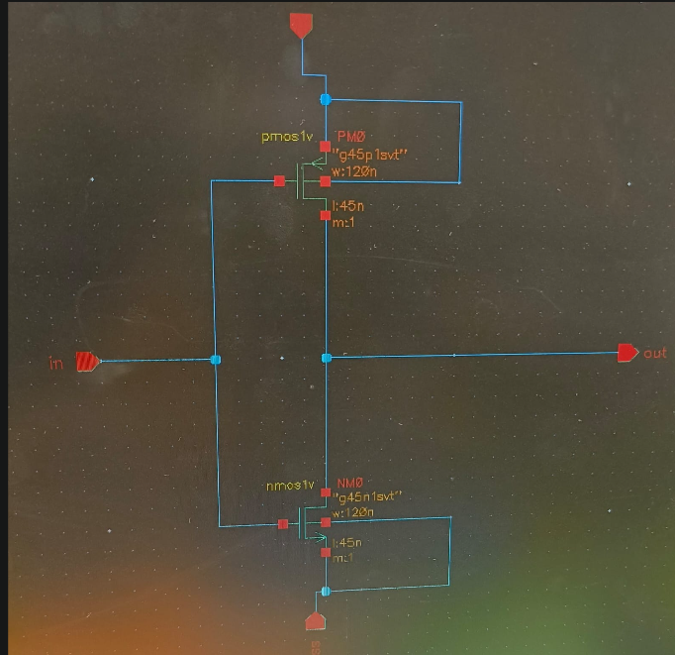

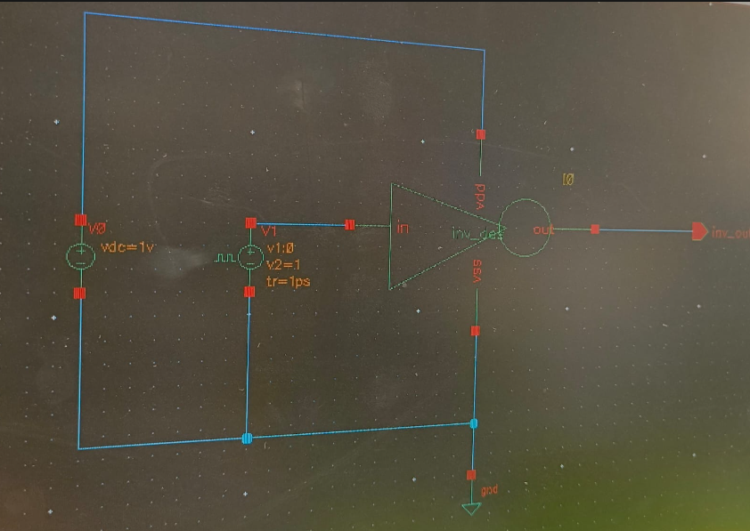

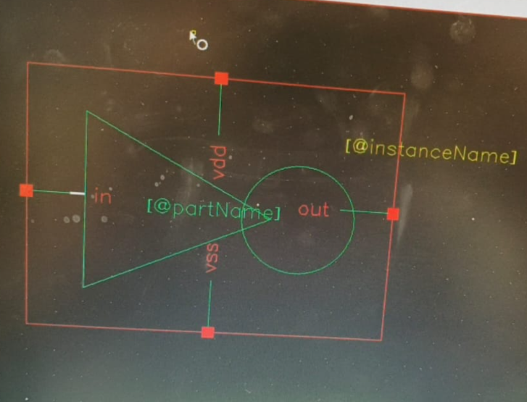

Output Parameter Table:
S.No. | Output Parameter | Theoretical / Expected Value | Practical / Simulated Value | % Deviation
1 | Fabrication sequence | Standard P-well CMOS flow | CMOS P-well fabrication sequence completed | 0% deviation
2 | P-well depth | As specified by process | 2 µm | 0% deviation
3 | Oxide thickness | 4 nm | 4 nm | 0% deviation
4 | P-well lateral dimension | As per design | 2 µm | 0% deviation
5 | Junction profile | Properly formed | P-well region formed in an n-type silicon substrate Record observation | 0% deviation
6 | Layer structure | Correct CMOS layers | N-type substrate, oxide, mask and P-well regions identified | 0% deviation
7 | Doped-region concentration | As per implant specification | P-well dimensions verified against the design | 0% deviation

Output:
